Unit 11 Regression Analysis

Learning Outcomes
- Explain the concept of Regression
- Interpret model fit, statistical significance, and coefficient interpretation
- Create scatter plots for model building
- Illustrate generalised linear model in R language

-------------------------------------------------------------------------------------------------------------------------------------

Dataset
We will be using marketing dataset to perform linear regression analysis in R. The dataset can be found on VLE.
We will now go over some key definitions (ensure you watch last week’s lecturecast and review this week’s reading for more information)

Importance of Variables
- Correlation is not causation. The variables could be completely unrelated and still appear to be correlated. For example, a study done New York in 2009 showed a “correlation” between ice cream sales in summer and murder rates (Ho, n.d.). So, can we conclude that an increase in ice cream purchases in New York causes an increase in homicides? Doubtful. Hence, it does not matter, in correlation, which variable is dependent, and which is independent.
- However, in regression this does matter. Which variable is X, and which one is Y is important as changing one or the other will generate a differing equation for the line of best-fit?
- Thus, the line predicting X from Y is not same as line predicting Y from X.
R-values
- Pearson correlation coefficient, r ranges from -1 to +1.
- Linear regression quantifies goodness of fit as R².
- the square of r from correlation will equal r² from regression.

Scatter Plot Example
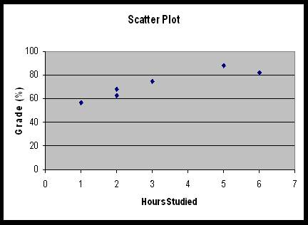
- A scatter plot is a graph of the ordered pairs (x,y) of numbers consisting of the independent variables, x, and the dependent variables, y.
- To identify if a relationship exists, easiest way is to place a straight line through the data points.
- This line can be described by formula of a straight line: y = mx + c or y = a+bX
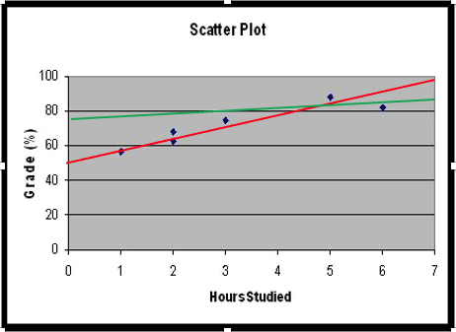

Residual
- Using the residuals, a best fitting line can be drawn.
- The residual is the distance between the observed y value and the calculated y value
- From the example, the green line has larger residuals in comparison to the red line

Least squares linear regression
- The best fit line is that line which has the smallest total sum of squared residual distances
- Least squares regression
- Software calculates least squares regression by changing the value of the gradient and constant to generate the minimal sum of squares

Procedure for Regression Calculation
- Inspect data on scatterplot
- Assess residuals
- Assess regression statistics

Assumptions for regression
- In linear regression, the relationship between dependent and independent variables in the underlying population must be linear
- Mean of residuals for all observations equal to zero
- Variance of spread of residuals is constant
- Residuals are normally distributed
- Residuals are independent of each other

Regression statistics
- Standard error of regression coefficients
- ANOVA table
- R² value

Output
- The most important value is the R² (adj) value
- This is the adjusted coefficient of determination
- Closer to 100% the better the regression equation can be used as a predictor

r² (adj.)
- r is a measure of correlation
- r² is this value squared. It is the proportion of variance accounted for by the line
- r²(adj.) takes into consideration degrees of freedom. This value is lower than the r² , preventing overfitting
- r²(adj.) is the value of interest

Standard error of coefficients
- The standard error of the coefficient measures the precision of the estimate of the coefficient. The smaller the standard error, the more precise the estimate.
- It provides the absolute measure of the typical distance that the data points fall from the regression line

ANOVA Table
- ANOVA table that identifies whether line could have arisen by chance from random data.

Regression analysis using R
Before performing liner regression analysis, let’s get to know about the dataset-
> print(marketing)
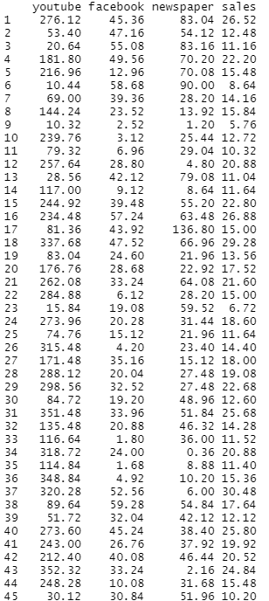
The dataset contains the impact of three advertising media (YouTube, Facebook and newspapers) on sales. We are now trying to predict future sales on the basis of advertising budget spent on YouTube.
Let’s develop a scatter plot to check sales units versus YouTube advertising budget.
This can be done using the following command:
ggplot(marketing, aes(x = youtube, y = sales)) +
geom_point() +
stat_smooth()

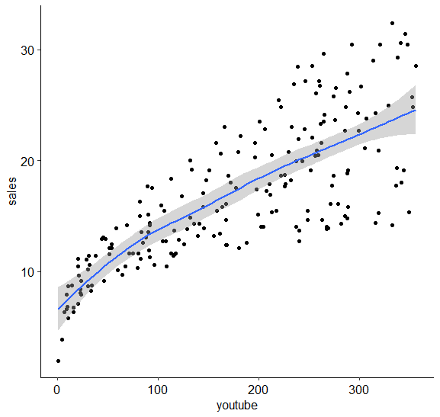

The scatter plot indicates that there is a linear relationship between the variables, sales and YouTube advertising.
Now, we will compute the correlation coefficient between two variables using the following command:
>-cor(marketing$sales, marketing$youtube)
[1] 0.7822244
From the above finding, it can be said that there is strong positive relationship between the two variables, sales and YouTube advertising.
The linear model can be developed by executing the following command-
> model<-lm(sales~youtube, data = marketing)
> model
Output
Call:
lm(formula = sales ~ youtube, data = marketing)
Coefficients:
(Intercept) youtube
8.43911 0.04754

The above results show the intercept and the beta coefficient for the YouTube variable and the estimated regression line equation can be written as follow:
Sales =8.44 + 0.048*(YouTube)
This can be interpretated as, for a YouTube advertising budget equal to zero, there will be a sale of
8.44*1000 = 8440 dollars.
Now, to get the statistical summary of the model, use the following command-
> summary(model)
Output
Call:
lm(formula = sales ~ youtube, data = marketing)
Residuals:
Min 1Q Median 3Q Max
-10.0632 -2.3454 -0.2295 2.4805 8.6548
Coefficients:
Estimate Std. Error t value Pr(>|t|)
(Intercept) 8.439112 0.549412 15.36 <2e-16 ***
youtube 0.047537 0.002691 17.67 <2e-16 ***
---
Signif. codes: 0 ‘***’ 0.001 ‘**’ 0.01 ‘*’ 0.05 ‘.’ 0.1 ‘ ’ 1
Residual standard error: 3.91 on 198 degrees of freedom
Multiple R-squared: 0.6119, Adjusted R-squared: 0.6099
F-statistic: 312.1 on 1 and 198 DF, p-value: < 2.2e-16

Interpretation
In the above example, both the p-values for the intercept and the predictor variable are highly significant. So, we can reject the null hypothesis and accept the alternative hypothesis. This means that there is a significant association between the predictor and the outcome variables.

References
Dancey, C.P. and Reidy, J., 2007 Statistics without maths for psychology. Pearson education.

Daniel, W.W. and Cross, C.L., 2018 Biostatistics: a foundation for analysis in the health sciences. Wiley.

Ho, L. (n.d.) Ice Cream Sales “Lead” to Homicide: Why? Available from: https://www.lifehack.org/624604/the-most-common-bias-people-have-that-leads-to-wrong-decisions#:~:text=Ice%20Cream%20Sales%20%E2%80%9CLead%E2%80%9D%20to%20Homicide%3A%20Why%3F&text=In%20a%20study%20done%20in,sales%20were%20hitting%20their%20peak

